Sequence Title

 | Pose | 3D model address | Comments
 | 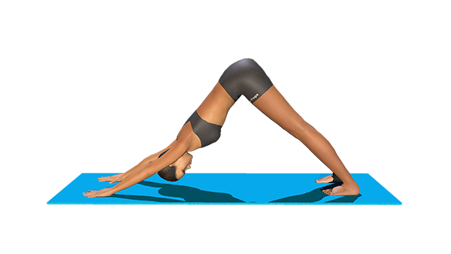 | https://www.lily-yoga.com/adho-mukha-svanasana-color-3d-models/ | - Press your hands firmly into the floor  - With an exhalation, push your thighs back and stretch your heels onto or down toward the floor  - Lengthen both sides of the trunk
Paste 3D model address
and hit ‘Enter’
 |  | Paste 3D model address and hit ‘Enter’
 |  | Paste 3D model address and hit ‘Enter’
 |  | Paste 3D model address and hit ‘Enter’
 |  | Paste 3D model address and hit ‘Enter’
 |  | Paste 3D model address and hit ‘Enter’
 |  | Paste 3D model address and hit ‘Enter’
 |  | Paste 3D model address and hit ‘Enter’
 |  | Paste 3D model address and hit ‘Enter’
 |  | Paste 3D model address and hit ‘Enter’
 |  | Paste 3D model address and hit ‘Enter’
 |  | Paste 3D model address and hit ‘Enter’
 |  | Paste 3D model address and hit ‘Enter’
 |  | Paste 3D model address and hit ‘Enter’
 |  | Paste 3D model address and hit ‘Enter’
 |  | Paste 3D model address and hit ‘Enter’
 |  | Paste 3D model address and hit ‘Enter’
 |  | Paste 3D model address and hit ‘Enter’
 |  | Paste 3D model address and hit ‘Enter’

